**Python Installation - Step by Step**

**By Sanjeev Sapre**

(These steps are prepared for “Python for Teenagers” Course)

Document Last updated – 12-Apr-2020

Contents

Checking if python is already installed. 3

Installing Python 5

# Checking if python is already installed.

As we are learning python . we need to install Python.

It is possible that your computer already has python. So lets see how to check that.

1. Click on windows start button

The windows menu will be opened up , it will look similar to this.

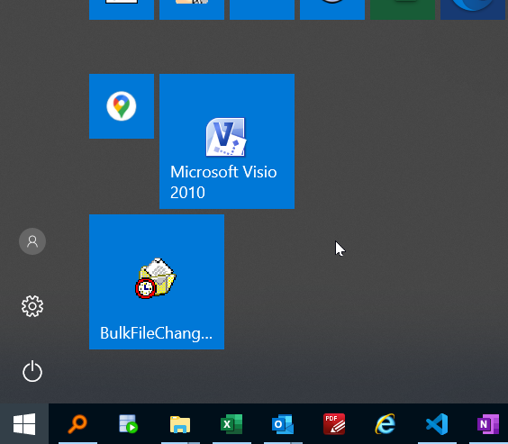

1. Type cmd and let menu show this command prompt option

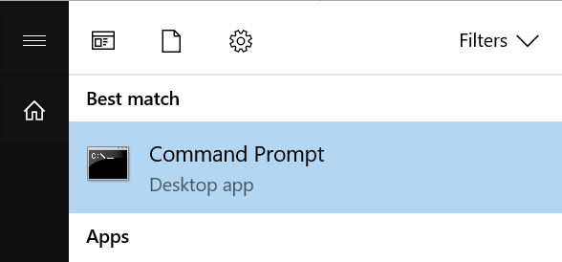

1. Click on and you will find a window like this

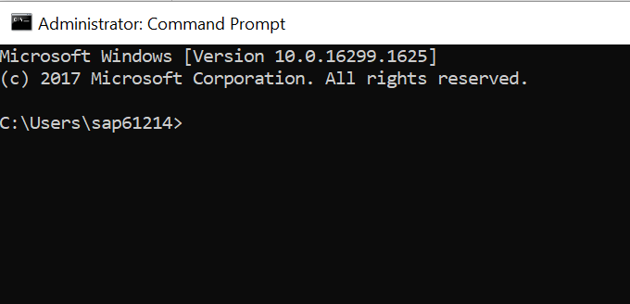

1. Type python and hit enter button

If you see this message

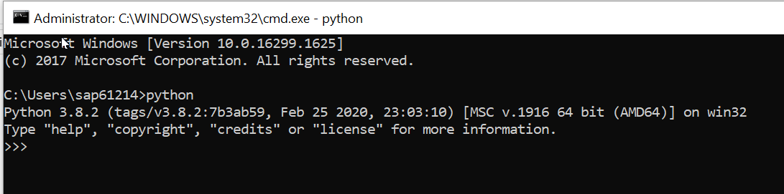

Then .. Congratulations ! You already have python installed.

Type exit() and press enter to close python. Then close command prompt.

But if it shows this message, then you have no properly installed python or no python installed.

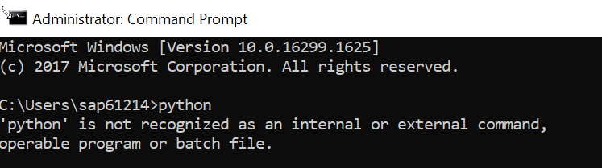

Go to installation section below to follow step by step how to install.

# Installing Python

Go to the python downloader site.

<https://www.python.org/downloads/windows/>

The site looks like this.

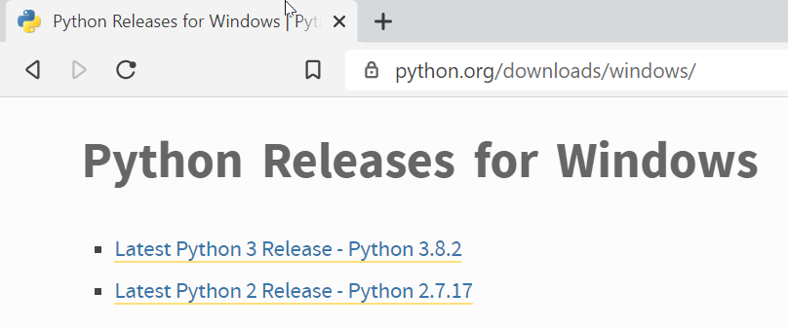

Search for

Download Windows x86 executable installer by clicking on it

Once the download completes, run that file by double clicking.

The installer will start, and following screen will appear.

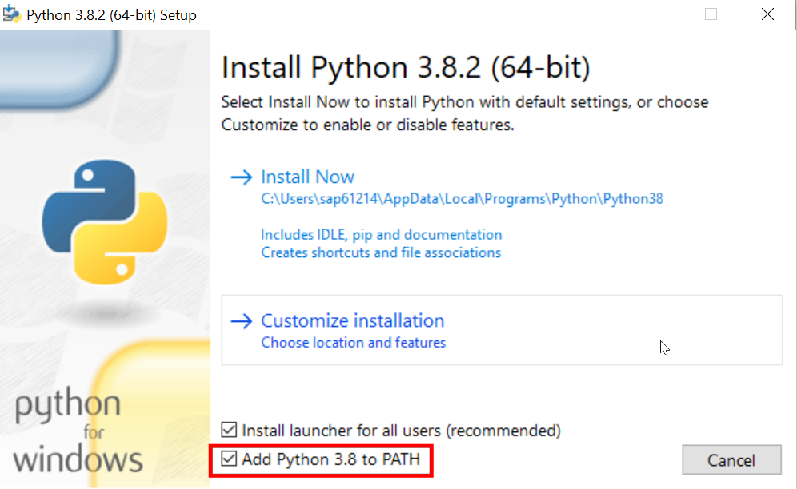

**Make sure to tick the check box “Add Python 3.8 to PATH” without fail.**

Then click on Install Now button and relax back.

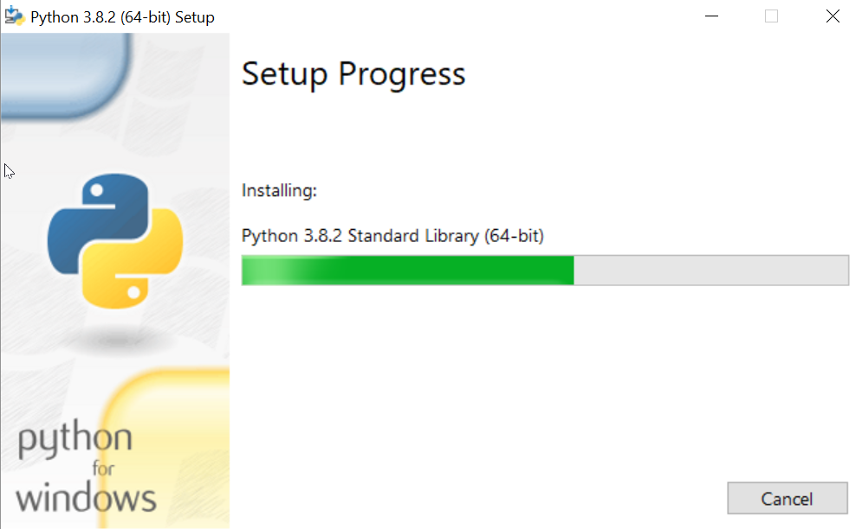

When the installation will complete successfully you will get this screen.

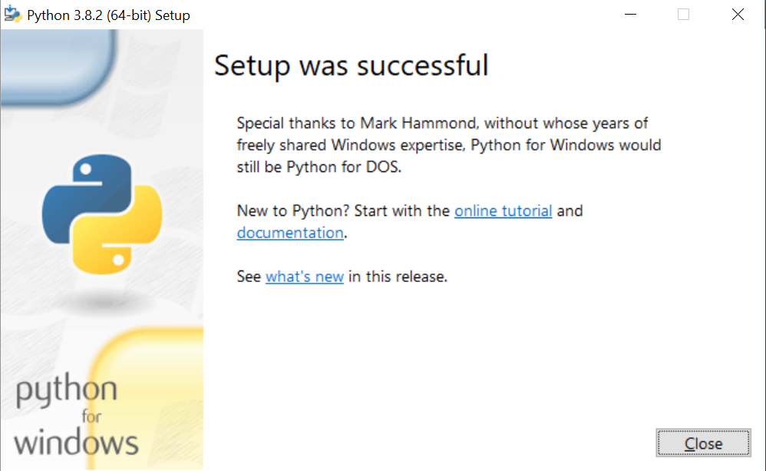

Now go back to “Checking if python is already installed.” Steps and confirm that it shows the python prompt.

Congratulations ! you have successfully installed python.